**ANIMAL HEALTH MONITORING DEVICE THROUGH BIOLOGICAL SENSOR**

**OVERVIEW**

In a farm, it is challenging for the farm caretaker to monitor the health and well-being status of all animals in a continuous manner throughout the day. Automated tools are needed to remotely monitor all pets on the farm and provide early alerts to the farm caretaker for situations that need immediate attention. With this goal, we developed a sensor board that can be mounted on the ears of individual pets to generate data on the animal’s activity, vocalization, and temperature

Precision swine production can benefit from autonomous, noninvasive, and affordable devices that conduct frequent checks on the well-being status of pets. Here, we present a remote monitoring tool for the objective measurement of some behavioral indicators that may help in assessing the health and welfare status—namely, posture, gait, vocalization, and external temperature. 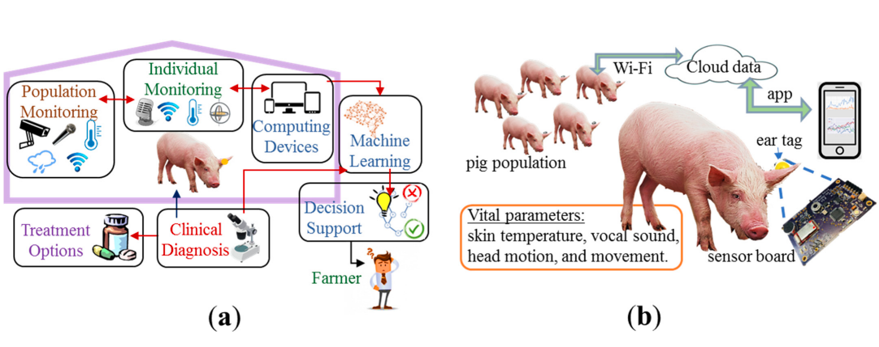

Overall theme for behavioral health monitoring in animal farms: (a) the animal farm is equipped with technologies to monitor individual animals and populations with mobile devices, data computing and storage units, machine learning, decision support tools, clinical diagnosis, and treatment options; (b) our measurement setup is shown. The ear tag with sensor board is attached to the ear lobe of individual pets to measure vital parameters and send the data through a smartphone app to the cloud.

The multiparameter electronic sensor board is characterized by laboratory measurements and by animal tests. Relevant behavioral health indicators are discussed for implementing machine learning algorithms and decision support tools to detect animal lameness, lethargy, pain, injury, and distress. The roadmap for technology adoption is also discussed, along with challenges and the path forward. The presented technology can potentially lead to efficient management of farm animals, targeted focus on sick animals, medical cost savings, and less use of antibiotics.

**BLOCK DIAGRAM**

Bluetooth BLE

**SENSORS**

HEART-RATE

OXYGEN

Buzzer

**WARNINGG**

MCU  
ESP32

Led

Temperature

Battery

**HARDWARE SPECIFICATION**

* ESP32 DEVKIT V1
* GY-906 Temperature Sensor
* Maxim Integrated MAX30100 oximetry / heart rate sensor
* Buzzer 3V
* Vibration motor 3v
* Led 3V
* Lithium Baterries

**SOFTWARE SPECIFICATION**

* Arduino IDE
* ALTIUM Designers
* Proteus